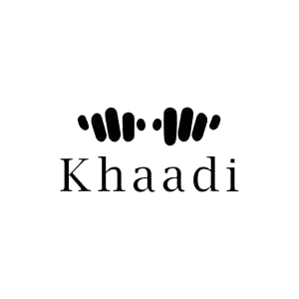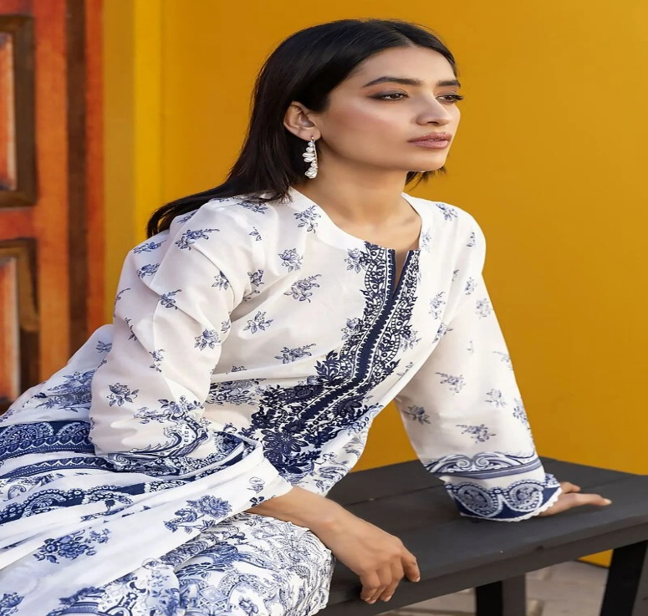

The outfit features intricate embroidery and embellishments, adding a touch of sophistication to the overall design. The blue and white color combination creates a visually appealing contrast, making it a standout piece in any gathering. The attention to detail and craftsmanship in this attire truly reflects the rich cultural heritage of Pakistan.

* **Details**
  + **Top Fabric:** Printed Cambric | Length 1.75m | Width 58in
  + **Dupatta Fabric:** Printed Lawn | 2.5m
  + **Campaign:** The Print Story

